Matthew Shiley HFCV Summer 2025 Plan & Notes

Plan
June 2025
Sunday | Monday | Tuesday | Wednesday | Thursday | Friday | Saturday
1 | 2 | 3 | 4 | 5 | 6 | 7
8 | 9 | 10 | 11 | 12 | 13 | 14
15 | 16 | 17 | 18 | 19  Juneteenth | 20 | 21
22 | 23  Start date  Make plan  Inventory | 24  Machine linkages | 25  J gone,  assemble/  do computer stuff | 26  Machine linkages  Work on 3D model | 27  Busy | 28
29 | 30  Work on 3D model

July 2025
Sunday | Monday | Tuesday | Wednesday | Thursday | Friday | Saturday
 |  | 1  Machine linkages | 2 | 3 | 4  Independence Day | 5
6 | 7  Busy | 8  Flight canceled, couldn’t get back | 9  Linkages | 10  Linkages | 11  Linkages | 12
13 | 14  Linkages (hopefully will finish lathing today) | 15  Linkages (finish milling?) | 16 | 17 | 18 | 19
20 | 21 | 22 | 23 | 24 | 25 | 26
27 | 28 | 29 | 30 | 31

August 2025
Sunday | Monday | Tuesday | Wednesday | Thursday | Friday | Saturday
 |  |  |  |  | 1  Last day in person | 2
3 | 4 | 5 | 6 | 7 | 8 | 9
10 | 11 | 12 | 13 | 14 | 15 | 16
17 | 18 | 19 | 20 | 21 | 22 | 23
24 | 25 | 26 | 27 | 28 | 29 | 30
31

Notes

Week 1: 6/23-6/26

Mon 6/23
- Met with Prof. Everbach to check in, layout direction for project.
- Checked in with J
  - J gone on wed 6/25
  - Need to familiarize myself with the lathe here
  - Plan on machining linkages tue 6/24 and thu 6/26
- Hope to finish linkages by next week so I can start assembly of the front frame
- Need more bolts
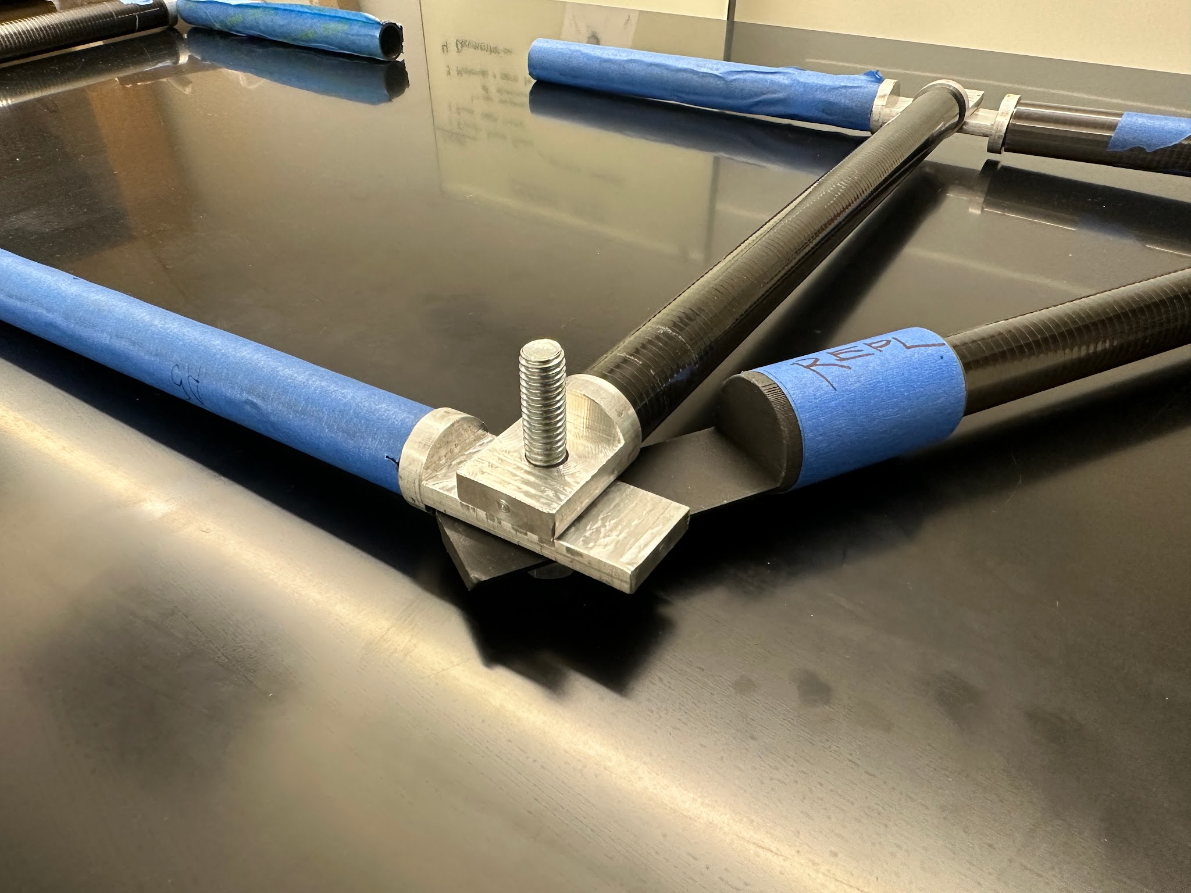
- Getting this three-member joint to lay flat seems like may be an issue. I should make sure everything is in line before I start making more linkages.
  - Nora informed me that washers were used before, but I think it would be good to have a design that doesn’t need them.
- I decided to make a model of the front section in Fusion to help me to figure out how to alter the linkage:
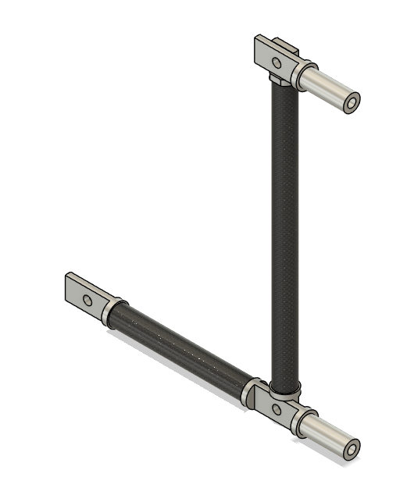
- This was a good exercise as it was my first time modeling with multiple components. I will ask Nora if turning this into a full model of the car is of interest. If so, I may work on this when I don’t have mechanical work to do.

- Instead of altering the 3D printed part, I filed down a side of the linkage so that the whole joint lies flat:
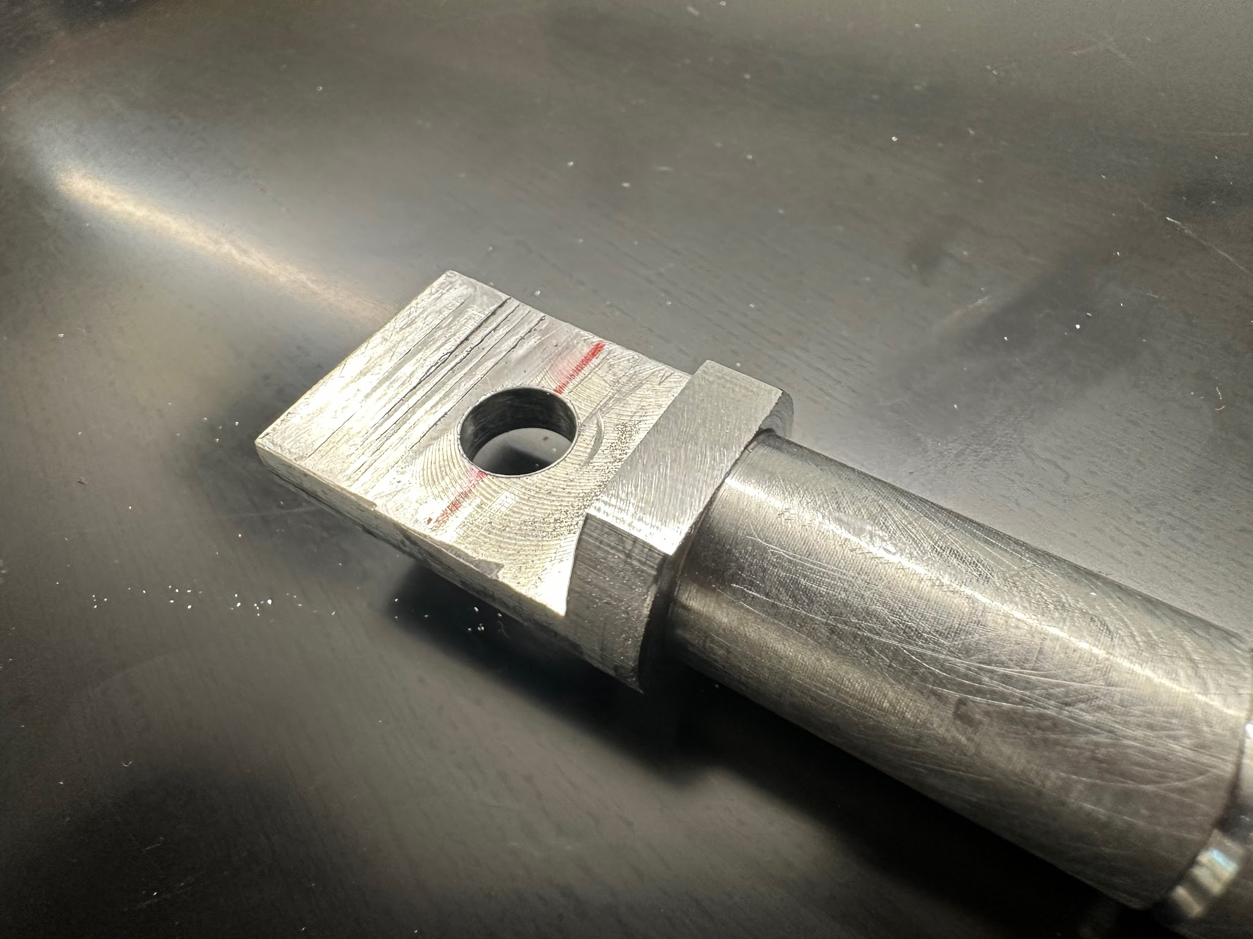

- Need for front:
  - 18 end members
  - 2 two-sided members (or three if the off-center hole is a problem)

- Need for back:

Tue 6/24
- Spent the day machining stopper linkages in the shop.
  - For the first couple hours, I familiarized myself with the lathe and other tools
- I managed to make 7, 9 more to go.

- I went up to SH124 to assemble as much of the chassis as I could:
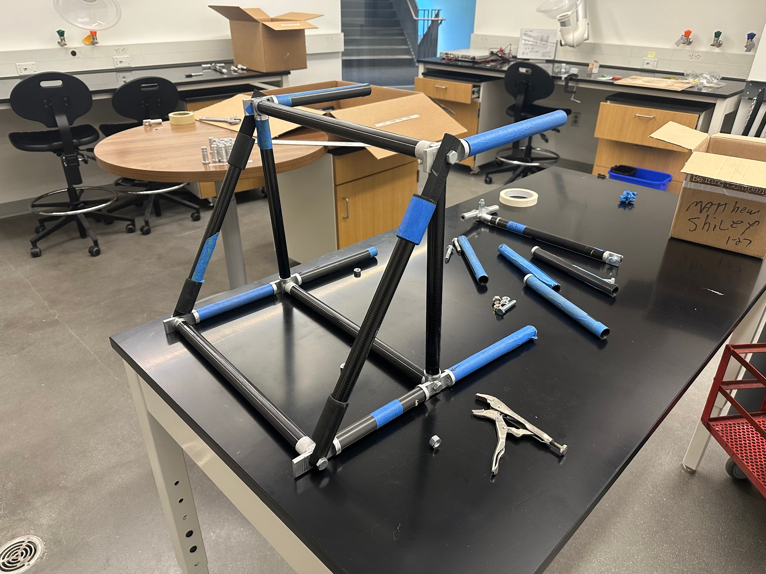

Wed 6/25
- Machined more stopper linkages in the shop. Managed to make five more.
  - Discovered that the threads needed to be tapped deeper, and the ½” relief at the top had to be bored out from ⅜” to 25/64”. This way, the tap was able to make it through.
- Attended pizza lunch & talk.
- Assembled more of the chassis with new linkages; screws still not going in far enough after tapping deeper. Not sure why.

Thu 6/26
- I decided to take a break from machining linkages because it was getting very tiresome.
- I re-assembled part of the chassis with the new linkages:

- For the rest of the day, I continued to work on the Fusion model of the car. There were several hiccups that I still haven’t found solutions to.
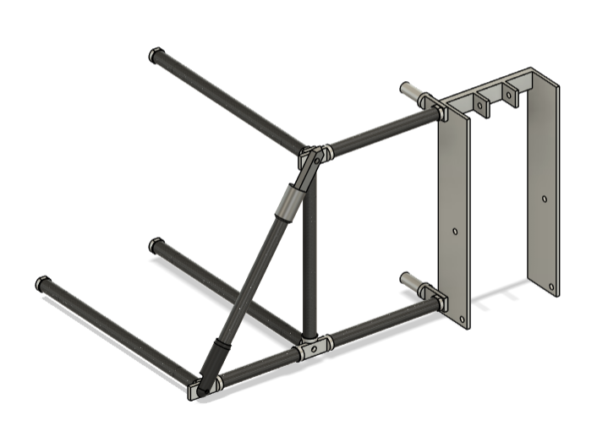

Week 2: 6/30-7/3

Mon 6/30
Made significant progress with the 3D model of the car and verifying how many of each type of linkage I need to make.
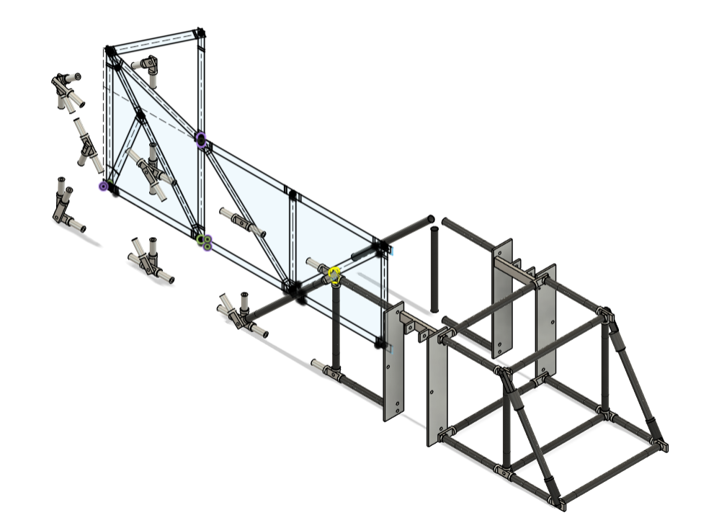

Week 3: 7/9-7/11

Wed 7/9
Still need to make:
- 12 x Stoppers
- 3 x suspension stoppers
- 3 x 1” single
- 6 x 1.5” single
- 2 x 1.5” single offset
- 2 x 1.75” single
- 7 x 2” double
- 2 x 2.3” single
- 2 x 2.3” single offset
- 1 x 2.3” double(side)
- 4 x 2.6” single

Fri 7/11
Still need:
- 2 x stoppers
- 7 x suspension stoppers
- 3 x 1” single
- 2 x 1.5” single offset
- 2 x 1.75” single
- 7 x 2” double
- 2 x 2.3” single
- 2 x 2.3” single offset
- 1 x 2.3” double(side)
- 4 x 2.6” single
- 1 x 2.8” double (center)
- 1 x 2.8” double (side)

Finished lathing almost all linkages. Still need:
- 2 x 2.3” single
- 2 x 2.3” single offset
- 1 x 2.3” double(side)
- 4 x 2.6” single
- 1 x 2.8” double (center)
- 1 x 2.8” double (side)

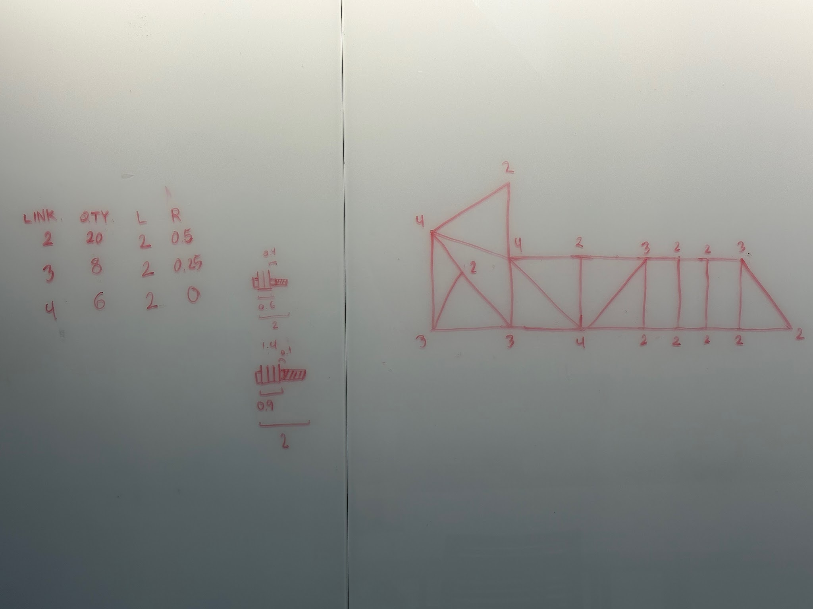
4 x no relief
4 x ¼” relief
2 x ½” relief

4 x 1.5” single
1 x 1.5” offset
1 x suspension stopper

